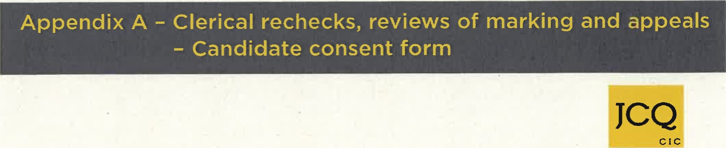 Clerical re-checks, reviews of marking and appeals
AQA

CCEA
OCR
Pearson
WJEC

Candidate consent form
Information for candidates
The following information explains what may happen following a clerical re-check, a review of marking and any subsequent appeal.
If your school or college submits a request for a clerical re-check or a review of the original marking, and then a subsequent appeal, for one of your examinations after your subject grade has been issued, there are three possible outcomes:
- Your original mark is lowered, so your final grade may be lower than the original grade you received.
- Your original mark is confirmed as correct, so there is no change to your grade.
- Your original mark is raised, so your final grade may be higher than the original grade you received.
To proceed with the clerical re-check or review of marking, you must sign the form below. This tells the head of your school or college that you have understood what the outcome might be, and that you give your consent to the clerical re-check or review of marking being submitted.
Candidate consent form
Centre number  18151 | Centre name  NOTRE DAME HIGH SCHOOL
Candidate number | Candidate name

Details of review
Awarding Body:

Qualification level:

Subject Title:

Component/Unit code:

I give my consent to the head of my school or college to submit a clerical re-check or a review of marking for the examination(s) listed above. In giving consent I understand that the final subject grade and/or mark awarded to me following a clerical re-check or a review of marking, and any subsequent appeal, may be lower than, higher than, or the same as the result which was originally awarded for this subject.
Signed: . Date:

